**Setting Up a Relay Station**

**(Using systemd)**

**NOTE: In place of the Adafruit Feather M0 LoRa modules, you can use any serial telemetry radios you choose.**

1. Hardware:

*Overview: A Raspberry Pi 2B or higher is used as an NTRIP client to pull RTCM3 correction data from rtk2go.com. An Adafruit Feather M0 LoRa module is used to transmit the corrections to an identical module that is connected to the GPS.*

An Adafruit Feather M0 LoRa module is mounted to a proto hat for a Raspberry Pi. Prepare the Feather by soldering its headers on and installing a u.FL female SMT connector.

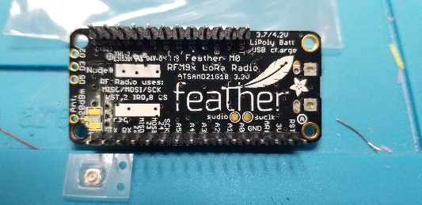 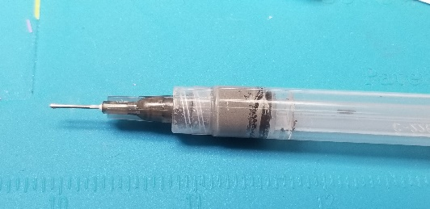 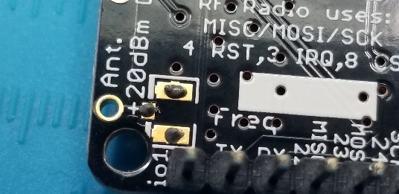 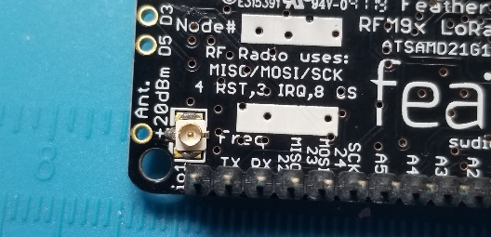 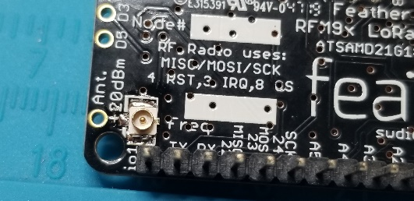

On the proto hat, the only connections are +5V, ground and serial out from the Raspberry Pi to the Feather on Pin 11. The antenna pigtail has a u.FL connector plugged onto the feather. A 4” cable tie keeps the cable from coming loose.

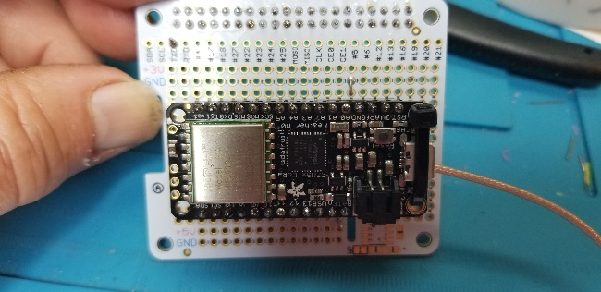 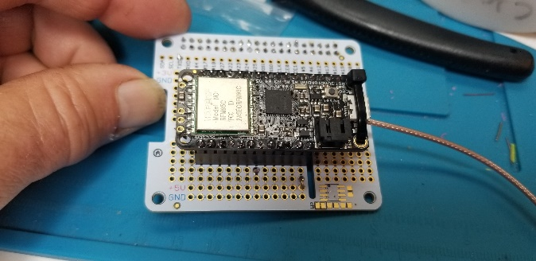 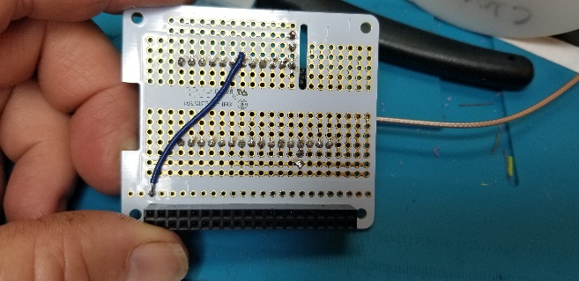 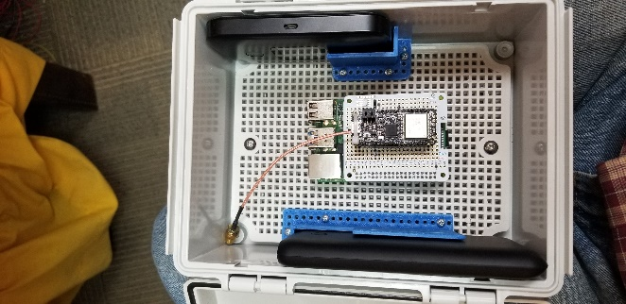

1. Installing the Adafruit Feather M0 LoRa Firmware

Using the Arduino IDE, load the latest version of the Serial to LoRa Transmit program. At this time it is named “Serial_to_LoRa_TX_V4-4.ino”. Firmware is available at <https://github.com/ktrussell/Serial_to_LoRa>.

1. Setting Up the Raspberry Pi:
2. Image the SD Card with the latest Raspian image. Set the username and password to your liking.
3. Create wpa_supplicant.conf in the boot (root) directory of the SD card. All possible Wi-Fi hotspots that the device might connect to should be defined in this file. NOTE: wpa_supplicant is now deprecated. Network Manager (nm) should be used instead.
4. Create an empty file named SSH in the boot (root) directory of the SD card.
5. Insert card in Raspberry Pi and boot it up.
6. Use an IP scanner such as Angry-IP Scanner to find the raspberry pi on the network.
7. SSH into the Pi using Putty or some other terminal program.
8. Change password on the Pi to MineGPS using the passwd command. (Note not necessary on newer versions (see #1 above).
9. Be sure all is up to date with “sudo apt-get update” and “sudo apt-get upgrade”.
10. Install git with “sudo apt install git”.
11. Download RTKLIB from github and compile with GCC with these commands:

git clone <https://github.com/tomojitakasu/RTKLIB.git>

cd ~/RTKLIB/app/str2str/gcc

make

1. The serial port name is different on different versions of the Raspberry Pi. On the Pi 4, it is ttyS0. If you run the command “dmesg | grep tty”, you will notice that the console is assigned to ttyS0 as follows: 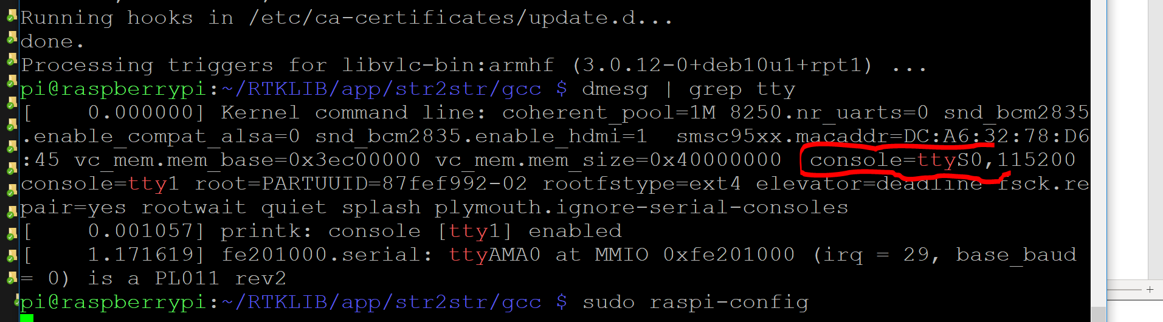
2. We have to go into raspi-config and change the serial port from being used by Linux to being just a serial port. The first 8 steps of <https://pimylifeup.com/raspberry-pi-serial/> generally explain how. Note that https://www.instructables.com/id/Read-and-write-from-serial-port-with-Raspberry-Pi/ is useful also. Here are the exact steps:
   1. Run “sudo raspi-config”.
   2. Go to “Interface options” – “Serial Port”. Select No to “Would you like a login shell to be accessible over serial?” Answer “yes” to “Would you like the serial port hardware to be enabled?” You should see a confirmation of the changes. Then exit raspi-config.
   3. Reboot in raspi-config (you will be asked if you want to as you exit) or with “sudo reboot”.
3. Now when you run the “dmesg | grep tty” command, you will see that ttyS0 is shown as serial: 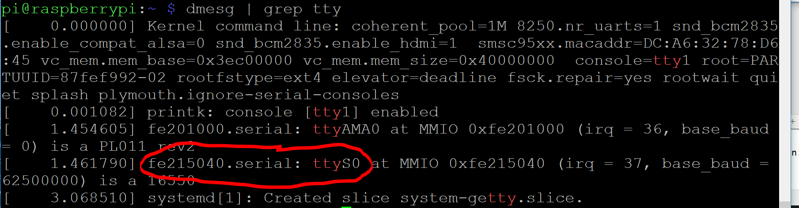
4. After that, you can make RTKLIB output the data with (note this is all one command on one line):

sudo ~/RTKLIB/app/str2str/gcc/str2str -in ntrip://user@email.com:pw@rtk2go.com:2101/DESIREDMOUNTPOINT -out serial://ttyS0:115200:8:n:1

(note the username (“user@email.com” above) needs to be a valid email address. It can be any valid email address. It is not registered with rtk2go.com. The password field (“pw” above) can be anything as no password is required for the client.)

1. You will see RTKLIB reading data from rtk2go.com:

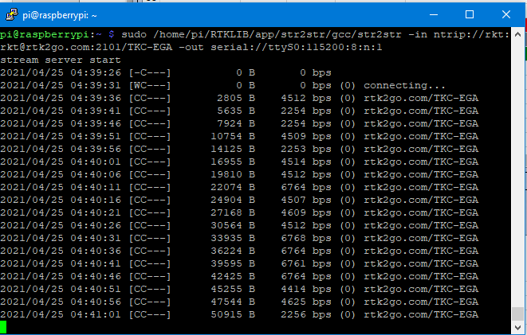

1. If you have a serial to USB converter connected to GND and the serial TX line on the Pi, you will see binary data in PuTTY or another terminal program.
2. Hit Ctrl-C to stop the command and return to the command prompt.
3. We will now create a service for str2str that we can control from the command line. <https://abhinand05.medium.com/run-any-executable-as-systemd-service-in-linux-21298674f66f> and the man pages were very helpful in getting this setup.
4. Copy the str2str executable to /usr/sbin with “cp ~/RTKLIB/app/str2str/gcc/str2str /usr/sbin”.
5. Create rtkrelay.service in /etc/systemd/system with the following contents:

[Unit]

Description=Service to use str2str to receive RTCM3 from an NTRIP caster such as rtk2go and output it over a serial port.

After=network.target

[Install]

WantedBy=multi-user.target

[Service]

Type=exec

ExecStart=/usr/sbin/str2str -in ntrip://user@email.com:pw@rtk2go.com:2101/DESIREDMOUNTPOINT -out serial://ttyS0:115200:8:n:1 > /dev/null &

WorkingDirectory=/home/ktrussell

Restart=on-failure

StandardOutput=syslog

StandardError=syslog

SyslogIdentifier=%n

1. Reboot (“sudo reboot”) and you are done!
2. Enclosure, Antenna and Tripod Details
3. Mount DIN rail to the back of then enclosure so that a surveyor’s pole clamp can clamp to it. On 8/25/2022, the distance from the outside of the left DIN rail to the outside of the right DIN rail was 3-3/16”.